**The History of Income Tax Department**

**in the North Eastern Region**

**The Beginning**:

In the year 1922, on the recommendations of the All-India Income Tax Committee appointed in 1921, the Indian Income Tax Act XI of 1922 came into being. This Act of 1922 marked an important change from the preceding Act VII of 1918 by shifting the administration of income tax from the hands of Provincial Government to the Central Government. The foundation of a proper system of tax administration in India was laid pursuant to the enactment of this Act.

In the same year, Shri Durgeswar Sarmah, ICS, Commissioner of Land Revenue, was given the additional charge of Commissioner of Income Tax, Assam, with headquarters at Shillong. This marked the beginning of Direct Tax administration in the North Eastern Region (There is no record of organized tax administration in the Region prior to 1922).

Soon thereafter, Income Tax Offices were opened at Sylhet (which was then part of the greater Barak Valley of Assam Province and is now in present day Bangladesh), Nagaon (in Middle Assam) and Dibrugarh (in Upper Assam) in 1926.

Income Tax Offices were subsequently established at Guwahati in 1932 and at Jorhat in 1934.

**Initial Administration:**

During the pre-independence era, there was no Income Tax Officer posted in Shillong. In fact, the jurisdiction over the erstwhile United Khasi & Jaintia Hills (comprising of modern day Meghalaya and extending upto Nagaon in the north, Sylhet in the south, Karbi Anglong and North Cachar Hills in the east) lay with the ITO Sylhet.

The then Inspecting Assistant Commissioner of Income Tax had his office in Shillong. Appeal matters were decided by the Appellate Assistant Commissioner based in Dacca (present day Dhaka).

The charge of Commissioner of Income Tax (CIT) was then held as on an additional charge by the Director of Land Records, Assam, an ICS Officer. One Shri Desai was the last Director of Land Records, who held the additional charge of Commissioner of Income Tax, Assam.

In 1945, Shri Rai Bahadur Govinda Das Bagri, an officer of the Central Revenue Department, was substantively appointed to the post of Commissioner of Income Tax for Assam and continued in that post till the end of 1947.

**Post-Independence era:**

Post-independence, Shri Herat Choudhury was appointed Commissioner of both Income Tax and Customs & Central Excise. The post of ITO Sylhet was also shifted to Shillong.

In 1952, the post of Commissioner of Income Tax, Assam was transferred to Calcutta as an additional charge held by the Commissioner of Income Tax (Central), Calcutta and re-designated as Commissioner of Income Tax, Assam, Tripura & Manipur (the princely states of Tripura and Manipur were merged with the Indian Union on 15th October 1949).

In 1957, the post of Commissioner of Income Tax, Assam with headquarters at Shillong, was revived and Shri K. D. Dholakia was appointed to the post. The post was placed under the administrative control of the Chief Commissioner of Income Tax, Patna.

In May 1979, Shri B M Sharma joined as the first Commissioner of Income Tax (Appeals) at Guwahati pursuant to the creation of the cadre of CIT (Appeals) in 1978.

**Cadre restructuring of 1996, 2000 & 2014:**

In the year 1997, pursuant to cadre restructuring of the Department, another post of Administrative Commissioner and a post of Director of Income Tax (Investigation) were created with headquarters at Guwahati

The Commissioner of Income Tax, Shillong continued to be the Cadre Controlling Authority till 25th February, 2000 when the Department was extensively restructured in stages leading to creation of the post of Chief Commissioner of Income Tax, North Eastern Region with headquarters at Guwahati. Shri A. Mukhopadhyay was the first incumbent of the post.

Subsequently, a post of Chief Commissioner of Income Tax, Shillong was also created in June, 2001.

One new post each of administrative Commissioner of Income Tax (CIT) were created at Guwahati, Jorhat and Dibrugarh on 24th January 2000. Also, one post each of CIT (Appeals) was created at Guwahati and Shillong. One post each of CIT (TDS), CIT (Audit), CIT (Computer Operations) and CIT (CIB) were also created for the Region with headquarters at Guwahati.

In the 2014 restructuring of the Department, the post of Chief Commissioner of Income Tax, NER, Guwahati was upgraded to the post of the Principal Chief Commissioner of Income Tax, North Eastern Region, Guwahati w.e.f. 15th November 2014.

The existing posts of administrative Commissioners at Guwahati, Shillong, Jorhat and Dibrugarh were upgraded to the posts of Principal CIT. The post of Director of Income Tax (Investigation) was upgraded to the post of Principal DIT (Investigation). The Region also got two new CsIT (Appeals)—one each at Jorhat and Dibrugarh.

**Size of the Department in NER:**

The post-independence period saw a rapid expansion of the Income Tax Department in NER. From a mere 5 stations in the pre-independence era, the number of stations where Income Tax Offices are located has increased to 29 till date. There are now Income Tax Offices in all the Seven Sister States.

**Interesting Snippets:**

(A) During the Second World War, a post of Excess Profits Tax Officer was created with headquarters at Shillong to tax the excess profits earned during the war years as part of the British Raj’s war effort.

(B) In the pre-independence period, there was no post of Inspector in the Income Tax Department. There was, however, a post of Examiner of Accounts; one each at Sylhet and Dibrugarh.

(C) Another interesting fact was that in the pre-independence period, there were only two Income Tax Practitioners in the entire North Eastern Region: Shri Purkayastha in Shillong and ShriM P Singh in Dibrugarh.

(D) Shri Rai Bahadur Govinda Das Bagri, Commissioner of Income Tax, Assam functioned as Commissioner of Income Tax in the morning and as Collector of Customs in the afternoon.

(E) Shri Ranadhir Chakravorty, who retired as PA to the Commissioner of Income Tax, Shillong fondly recalled that a fully liveried peon was always standing to attention in front of Shri Bagri’s chamber. He reminisced emotionally on his having accompanied Shri Bagri to Delhi just before Partition and being stranded in Calcutta on the way back because of communal riots associated with the Partition.

**Acknowledgement:**

The Pr.CCIT NER, Guwahati places on record his deep appreciation and acknowledgement of the valuable contributions made by Shri Dinesh A.J. Sawkmie, IRS 1991 as well as by other officials—past and present—towards compiling the history of the Department in NER.

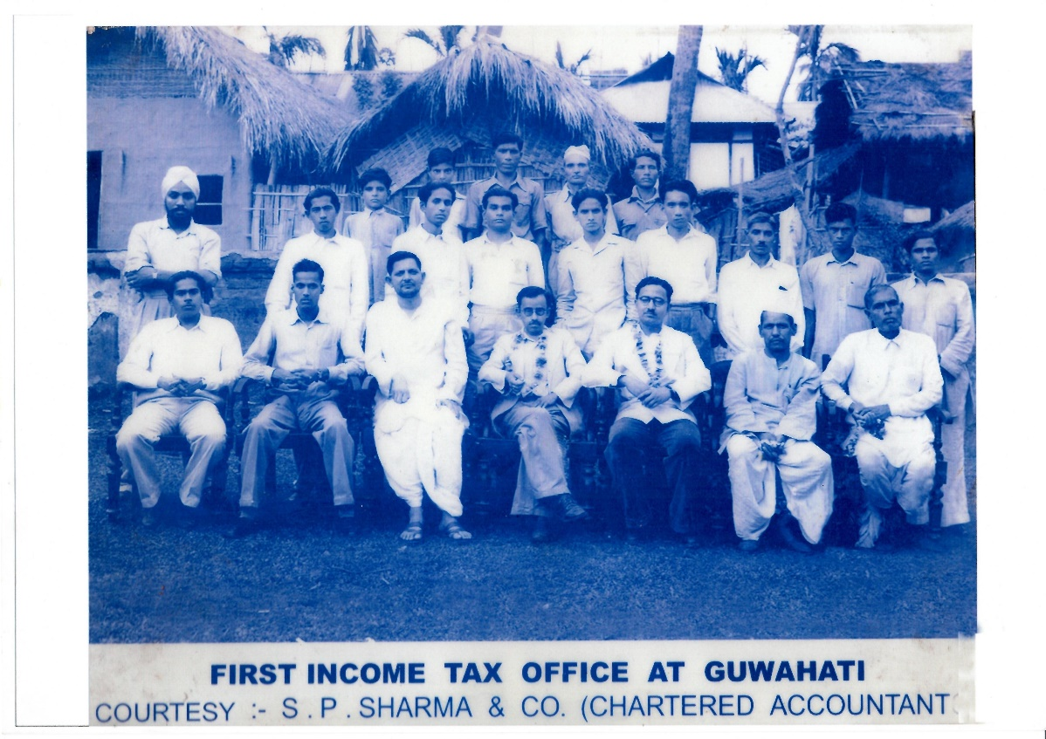**Down Memory Lane**

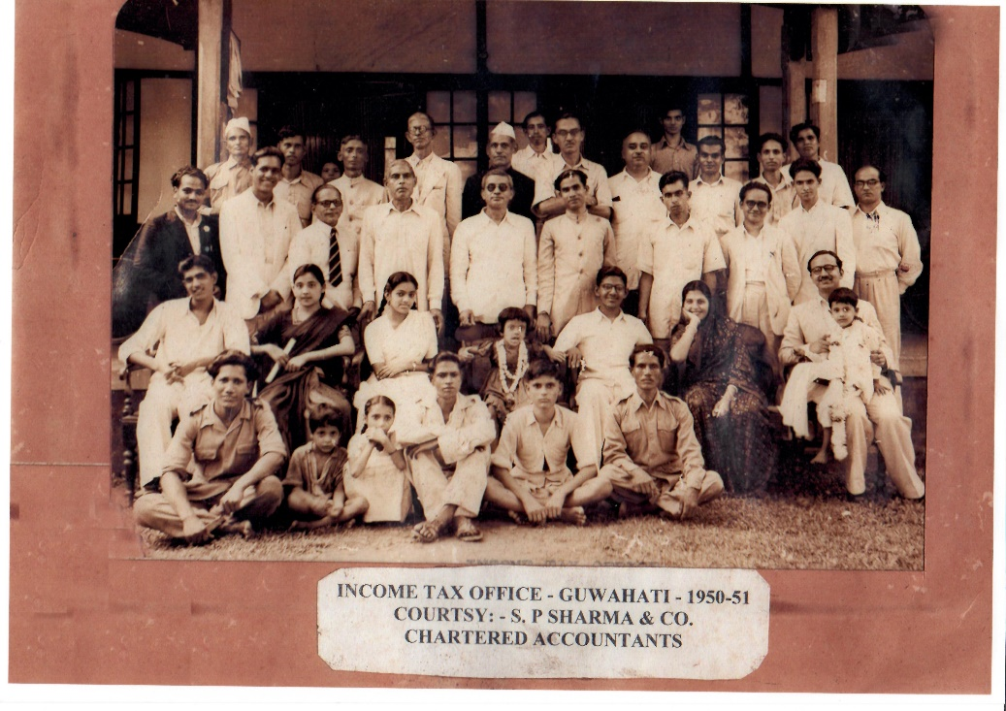

**Roll of Honour**

The dates of setting up of Income Tax Offices at various stations in NER after Independence together with the names of

the first incumbents are as follows:

|  |  |  |
| --- | --- | --- |
| Station | Date of setting up | Name of the 1st incumbent |
| Agartala | 15th October, 1949 | Shri Parsh Ch. Bhattacharjee |
| Gauripur/Dhubri | June 1951 | Shri H. C. Sarma |
| Tezpur | August, 1952 | Shri Kamakhya Ghosh |
| Sivasagar | 1st August, 1957 | Shri Abu Ali Barbhuyan |
| Digboi | 15th September, 1959 | Shri Pannalal Das |
| Tinsukia | 15th September, 1959 | Shri Abu Ali Barbhuyan |
| Imphal | January, 1965 | Shri S. K. Dutta |
| Karimganj | 1967 | Shri A. K. Mandal |
| Golaghat | 2nd February, 1969 | Shri A. K. Dey |
| Nalbari | 18th August, 1970 | Shri M. Haque |
| Dimapur | 1971 | Shri V. Dongzathang |
| Dharmanagar | 1st October, 1981 | Shri T. K. Bhattacharjee |
| North Lakhimpur | 15th July, 1982 | Shri R. K. Das |
| Bongaigaon | 1st July, 1983 | Shri B. B. Das |
| Duliajan | 1st January, 1993 | Shri K. P. Sarma Biswas |
| Barpeta Road | 26th February, 2004 | Shri Sujit Kumar Sen |
| Mangaldoi | 15th November, 2014 | Shri Nidhuban Ghosh |
| Morigaon | 15th November, 2014 | Shri Pratap Das |
| Goalpara | 15th November, 2014 | Shri Dulal Ch. Saha |
| Byrnihat | 15th November, 2014 | Shri K.G. Kar |
| Udaipur | 15th November, 2014 | Shri Biswajeet Bhattacharjee |
| Itanagar | 15th November, 2014 | Shri Sanjib Das |
| Aizawl | 15th November, 2014 | Shri Ranabir Roy |

**Budget Collection of NER in the new millennium**

|  |  |
| --- | --- |
| Financial Year | Budget Collection (Rs.) |
| 2000-01 | 427 cr |
| 2001-02 | 772 cr |
| 2002-03 | 799 cr |
| 2003-04 | 1227 cr |
| 2004-05 | 1438 cr |
| 2005-06 | 1711 cr |
| 2006-07 | 1759 cr |
| 2007-08 | 1777cr |
| 2008-09 | 1839 cr |
| 2009-10 | 2982 cr |
| 2010-11 | 3584 cr |
| 2011-12 | 4451 cr |
| 2012-13 | 5182 cr |
| 2013-14 | 5317 cr |
| 2014-15 | 4501 cr |
| 2015-16 | 5219 cr |
| 2016-17 | 6082 cr |
| 2017-18 | 7097 cr |

The revenue collections of NER have leapfrogged from **Rs.427 cr** during **FY 2000-01** to **Rs.7097 cr** during **FY 2017-18**. This translates to a **CAGR of 17%** (which is higher than the national average).

For **FY 2018-19**, the revenue collection target for the North Eastern Region has been fixed at **Rs.8357 cr**.